Web API in .Net Core
Tools : Visual Studio 2022 Back End : SQL Server
Steps
- Create Web Api Project in .Net Core in Visual Studio 2022

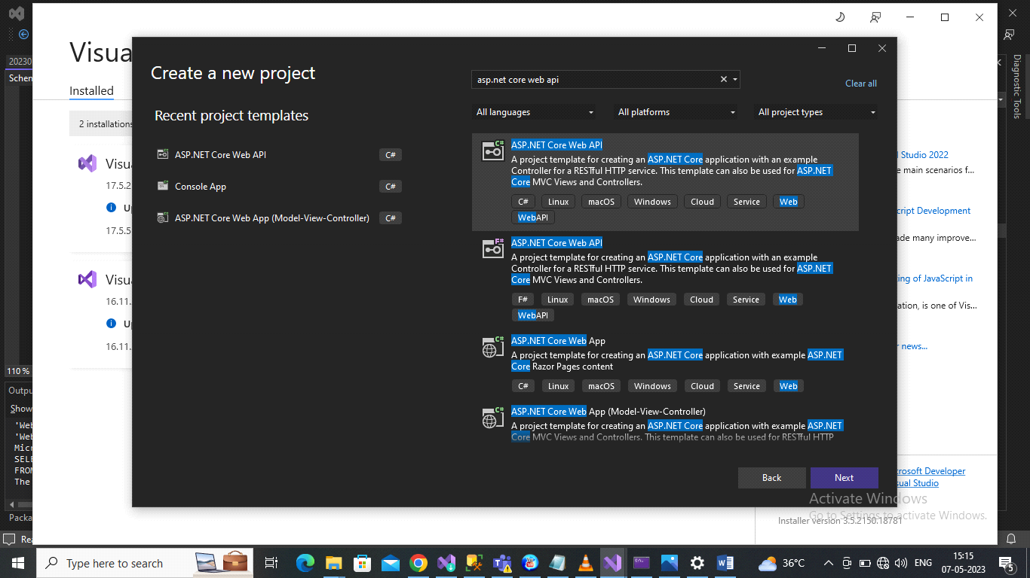

Add Project Name
My project name is CrudInCoreWebAPI and click next button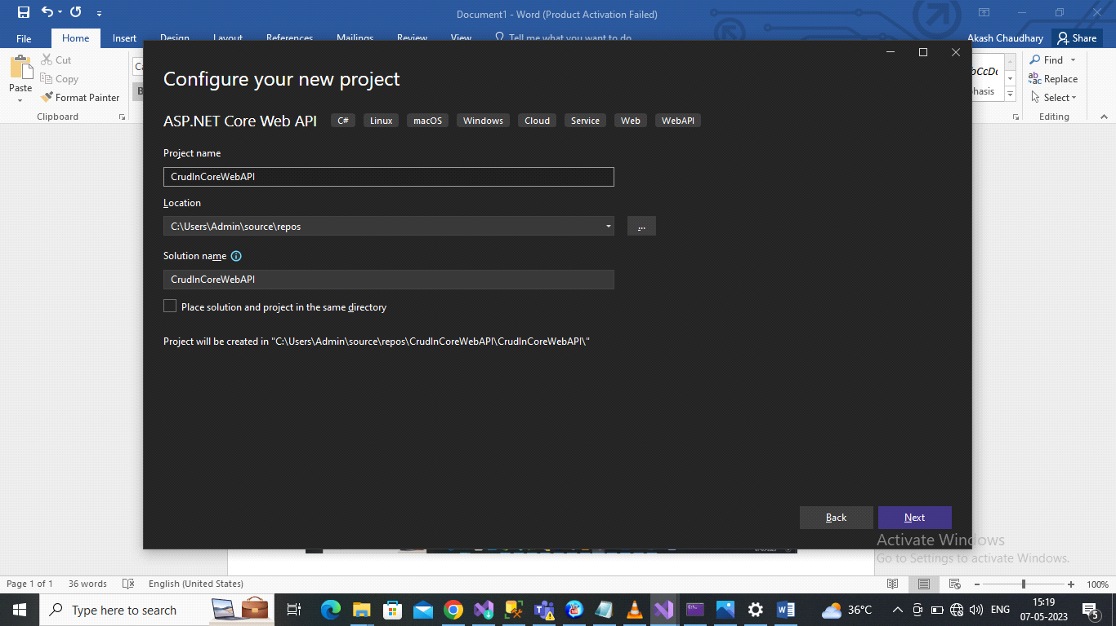
And Create the project
- Now Install the important packages.

Right Click on Dependencies and choose Manage Nuget Package
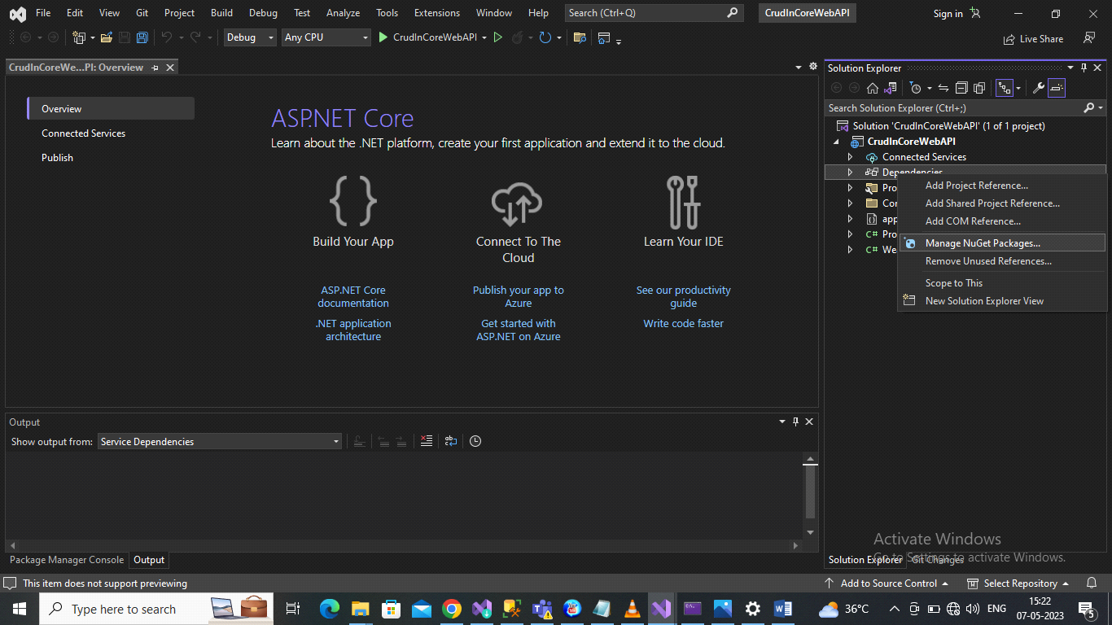
Choose Browse and search
microsoft.entityframeworkcore
microsoft.entityframeworkcore.sqlserver
microsoft.entityframeworkcore.tools
Newtonsoft.Json(choose latest version)
Microsoft.aspnetcore.cors (choose latest version)
Install all these packages with same version with internet connectivity.
I have choose latest version 7.0.5
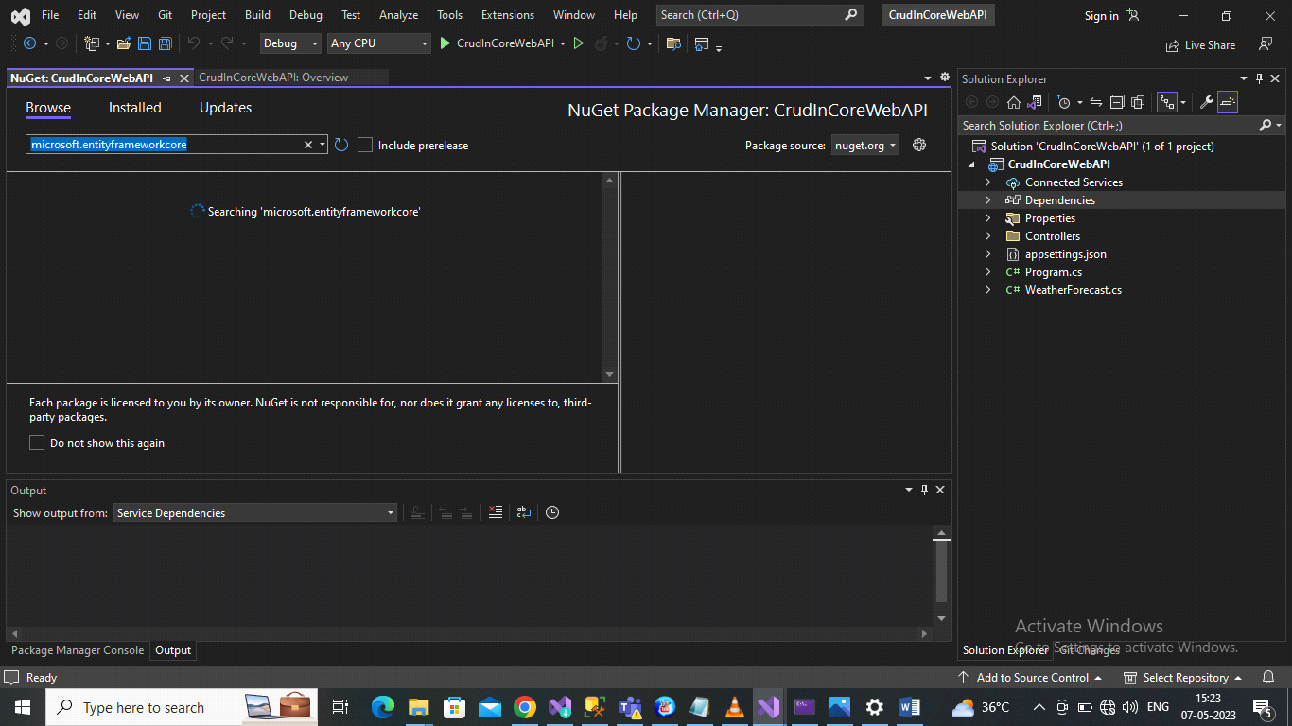
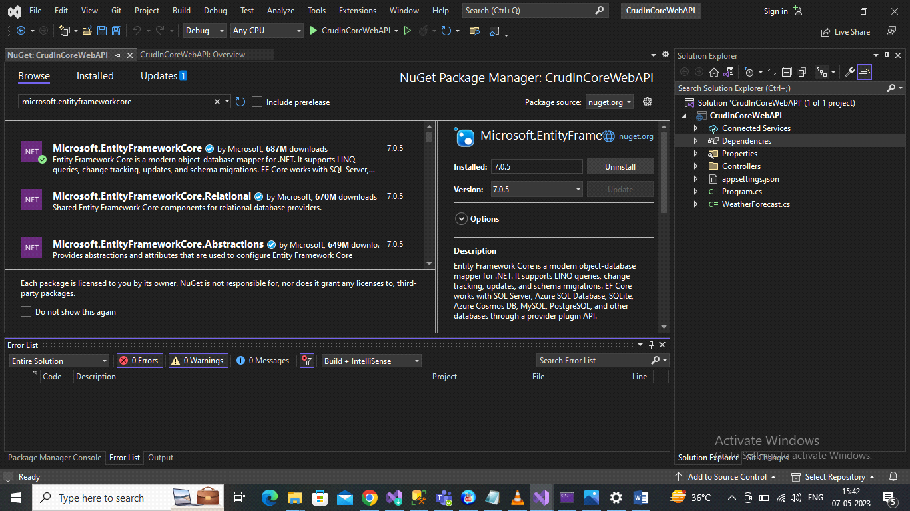
After installation Build the project
3)Open Appsettings.json file and add connection string.
"ConnectionStrings": {
"connection": "data source = DESKTOP-B8SJS28; initial catalog = test7523; trusted_connection = true; TrustServerCertificate=true"
},
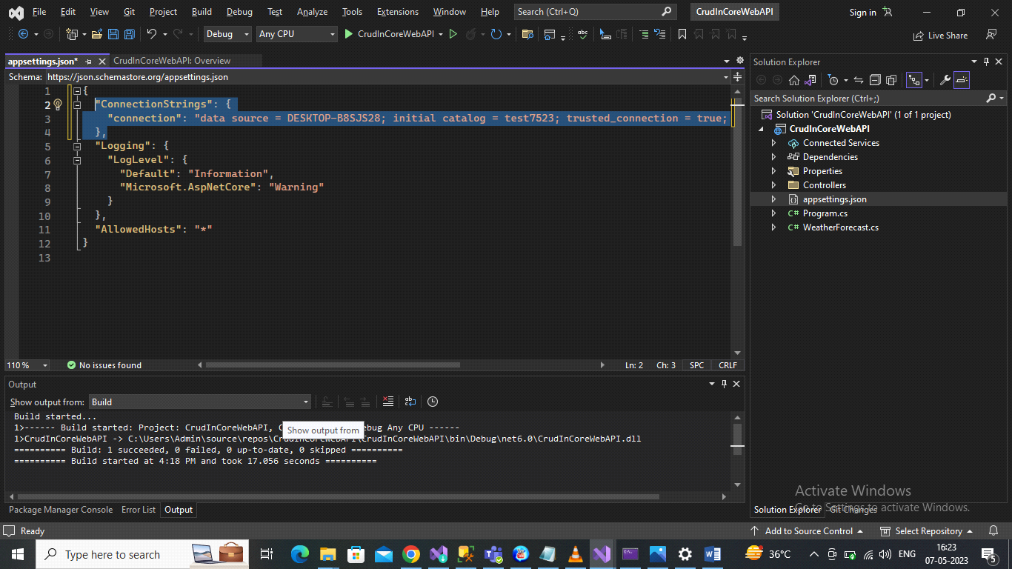
Now right click on project name choose Add and choose new folder
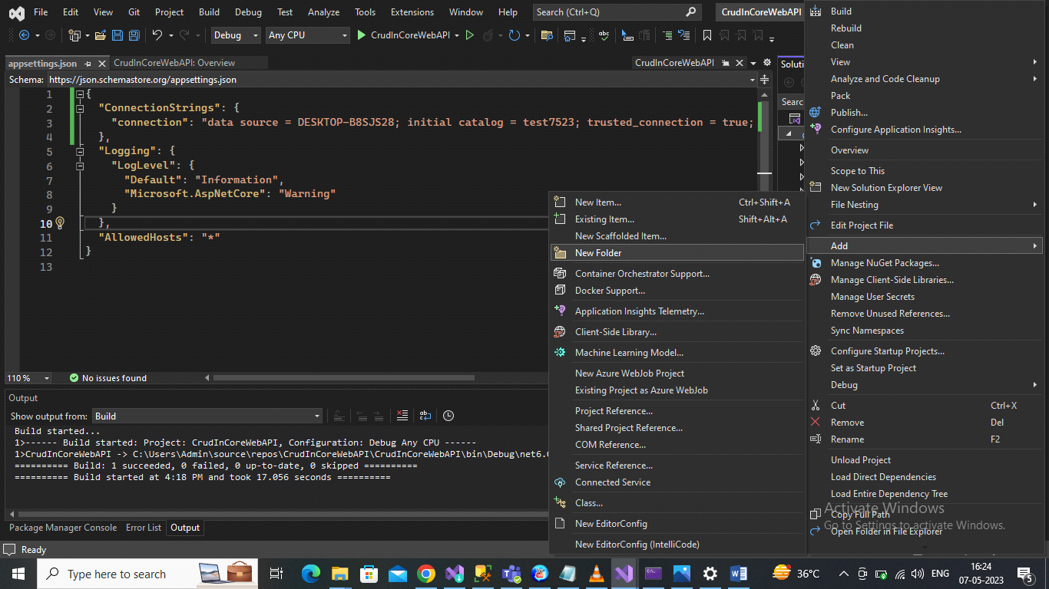
I have create Model folder.
Now right click on this Model Folder and add two class
Class1 name is DatabaseContext
Class2 name is tblusers
You can give any name
Add this code in DatabaseContext file
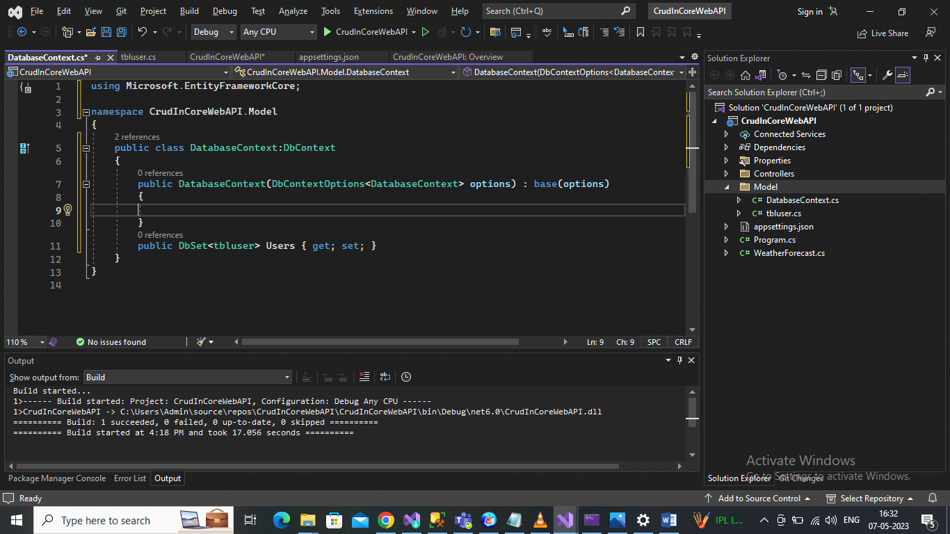

Add below code in tbluser file
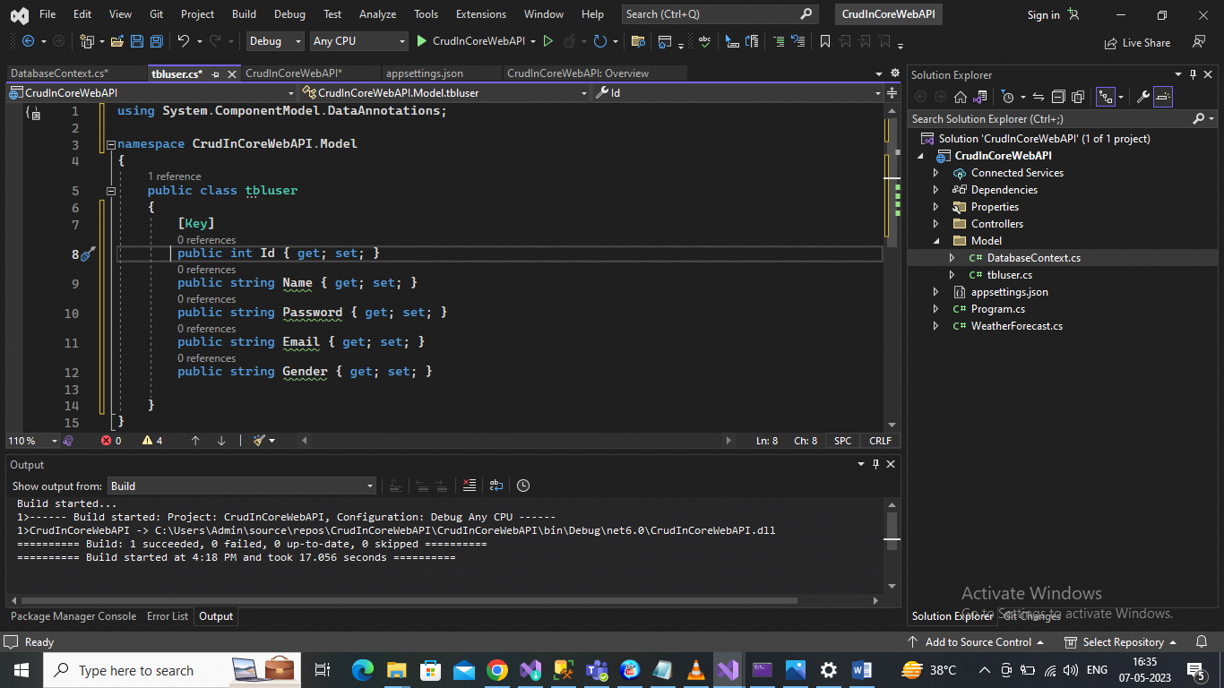
Add below code in program.cs file
builder.Services.AddDbContext<DatabaseContext>(options =>
{
options.UseSqlServer(builder.Configuration.GetConnectionString("connection"));
});

Now choose > tools in the top choose >Nuget Package Manager > Package Manager Console
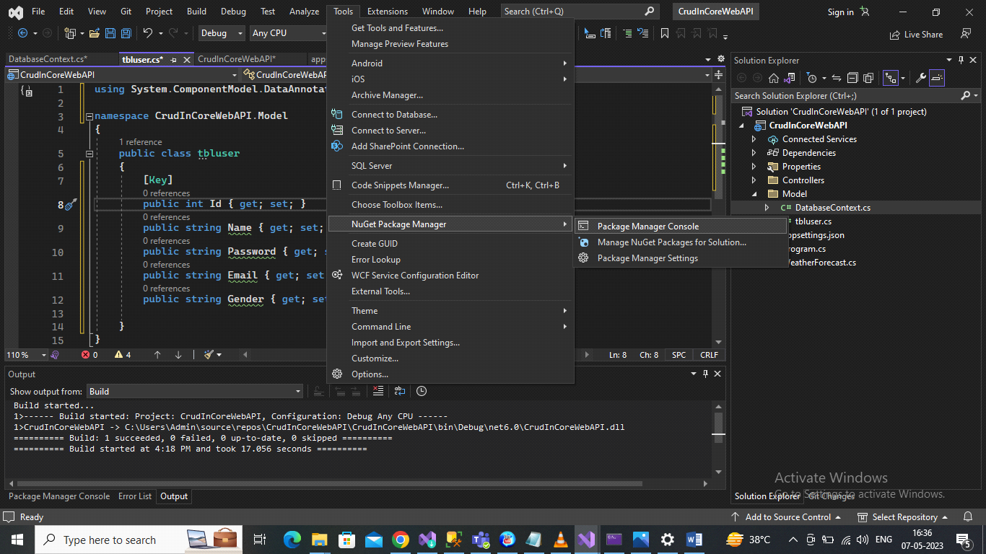

Apply Migrations in package manager console
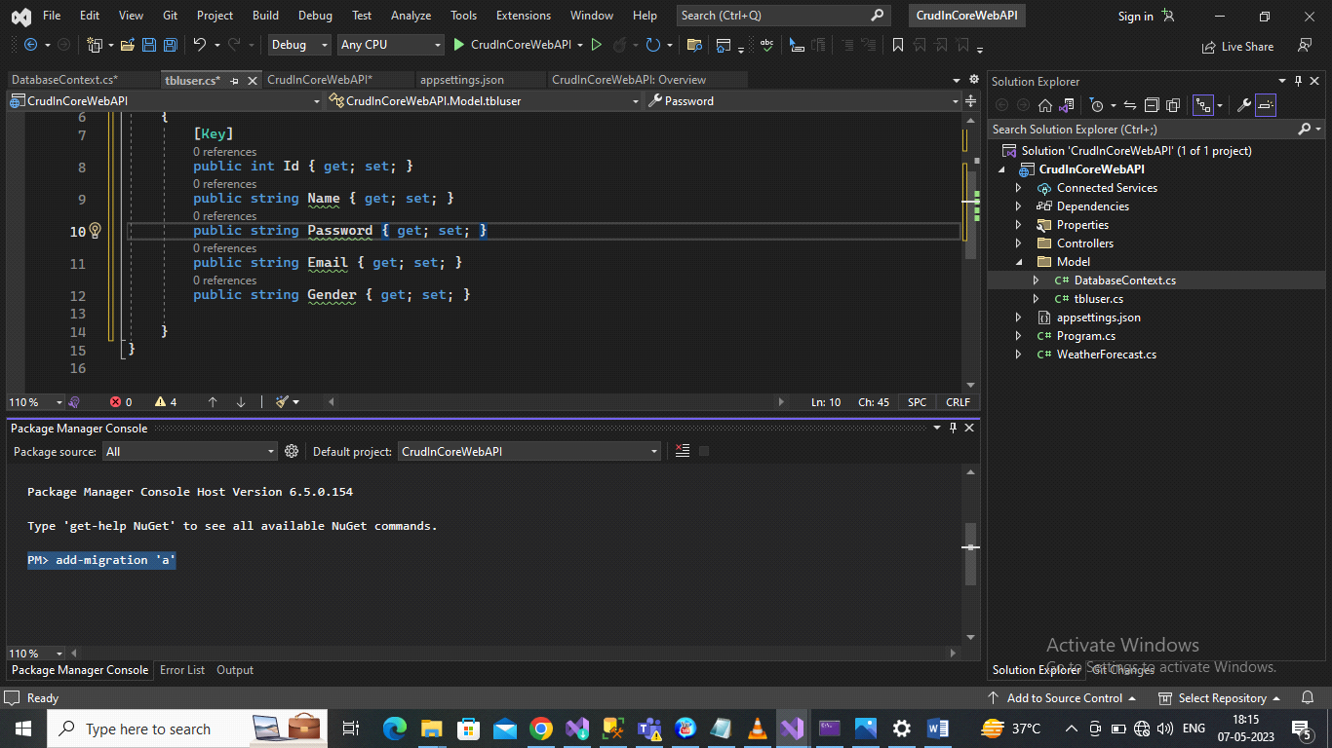
Add-migration ‘name’
Update-database
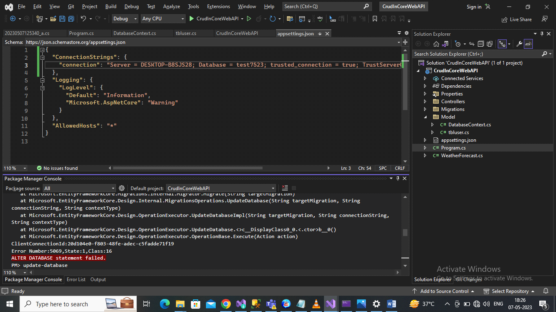
It showing
ALTER DATABASE statement failed.it showing This error.
Fix These
Go to Appsettings.json file and Replace Data source with Server
And initial catalog to Database
"ConnectionStrings": {
"connection": "Server = DESKTOP-B8SJS28; Database = test7523; trusted_connection = true; TrustServerCertificate=true"
},
Now run update-database in package manager console
And check database
Database with name of test7523 is created & also table is created

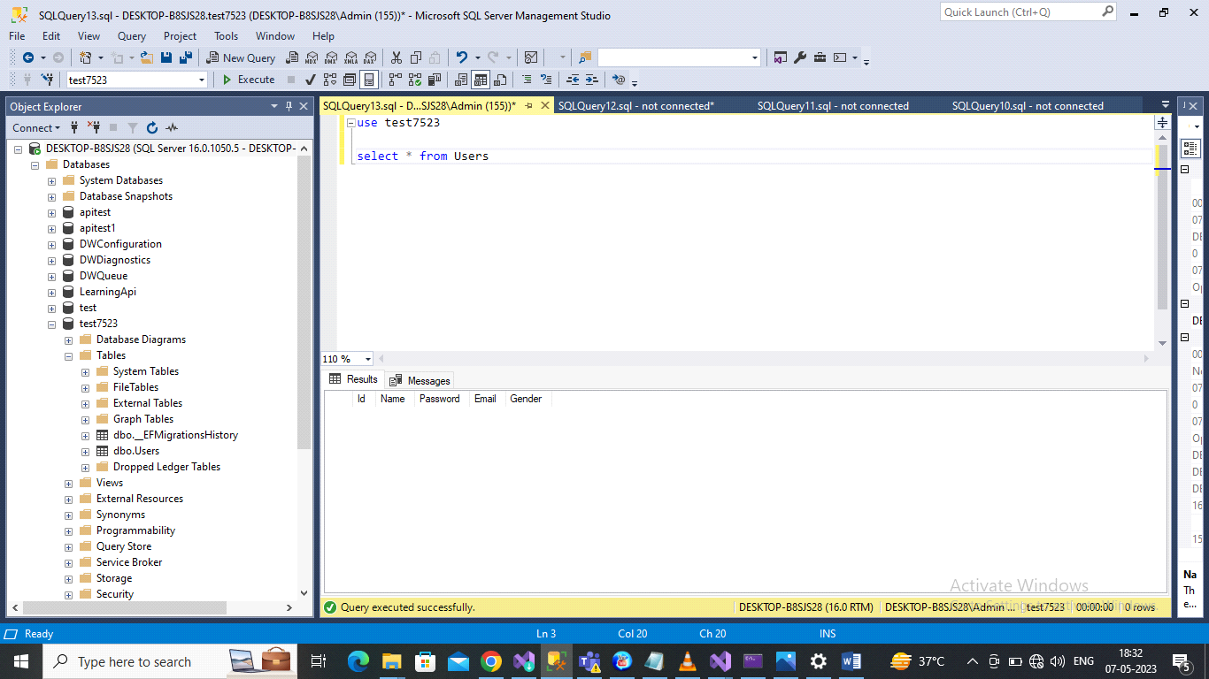

Now Add Api Controller

Right click on controller and add controller
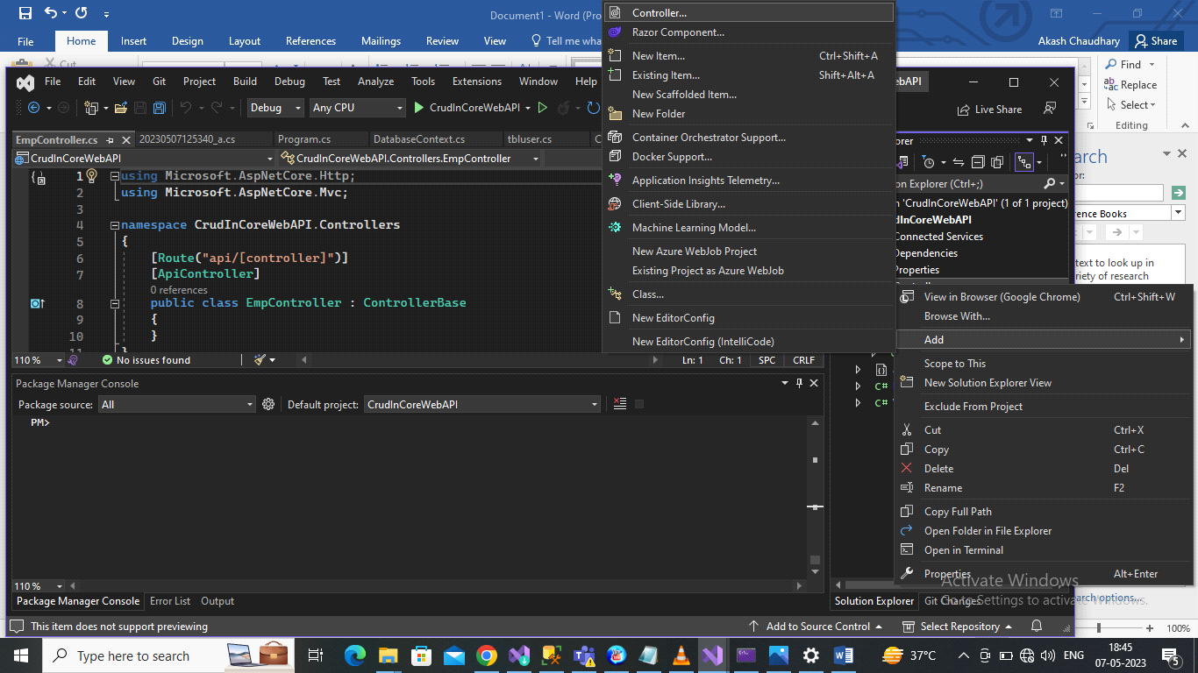
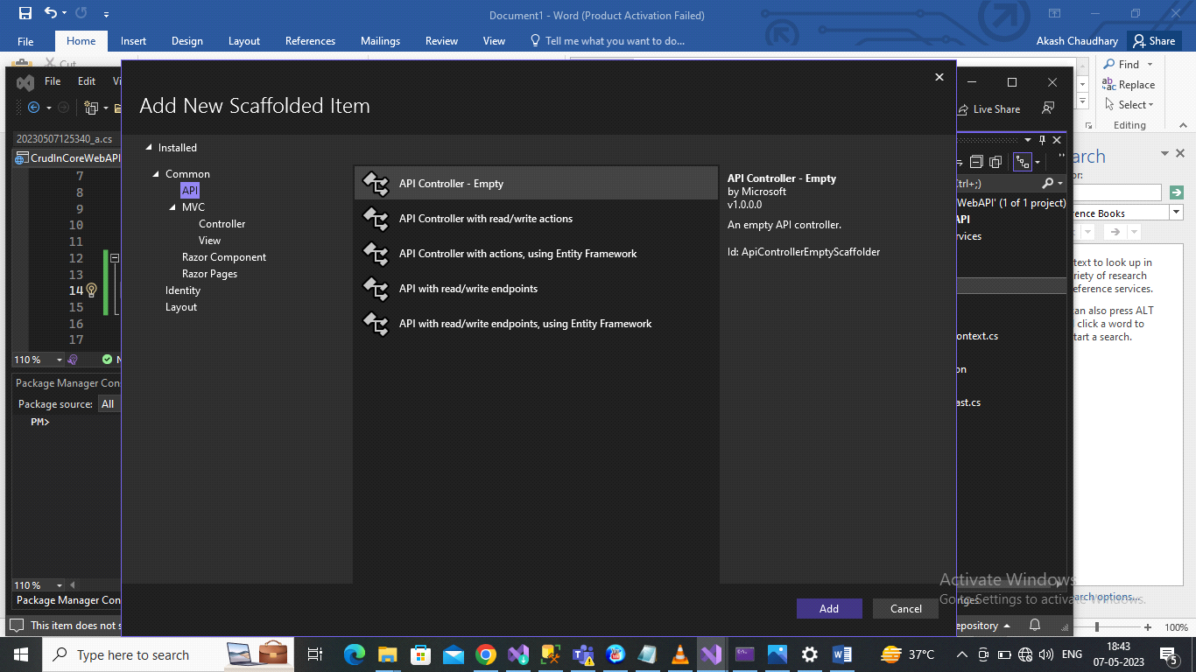

Give controller name Emp and add
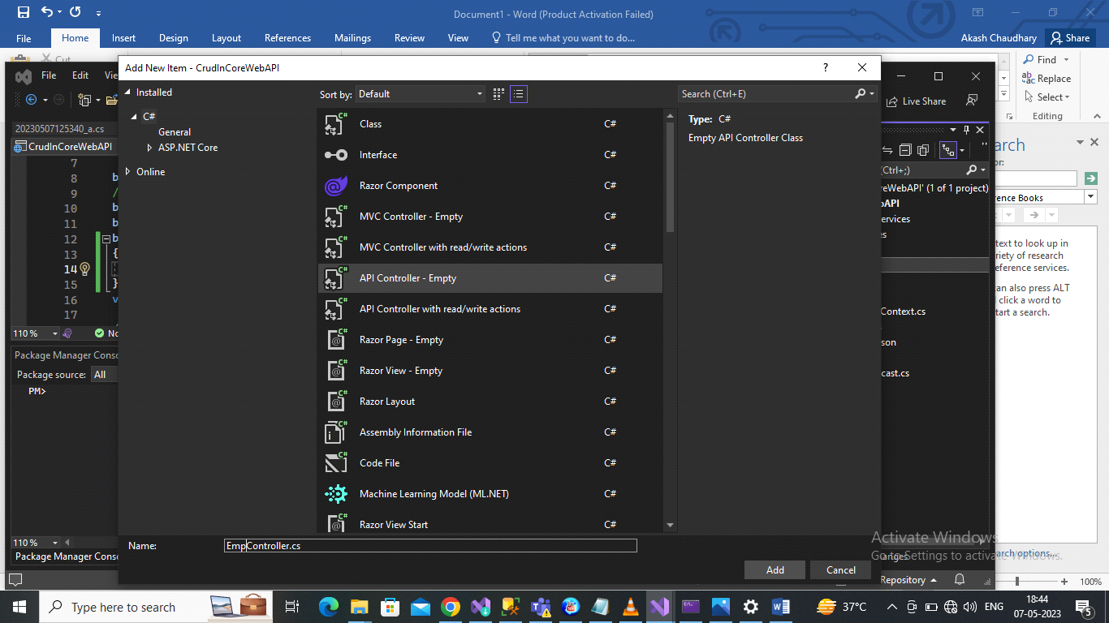

It’s like below
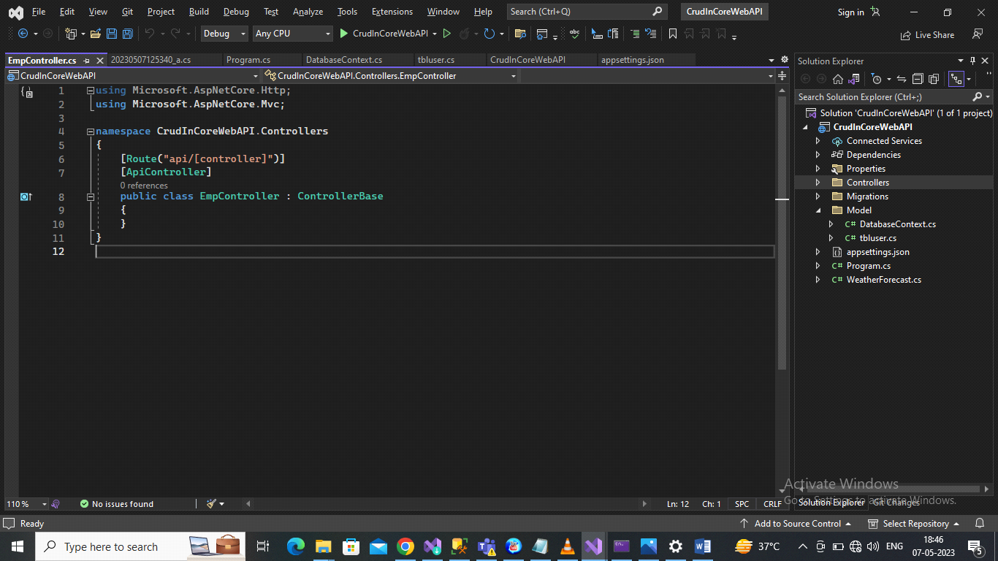

Now add below code inside controller
public DatabaseContext _Db;
public EmpController(DatabaseContext Db) {
_Db = Db;
}
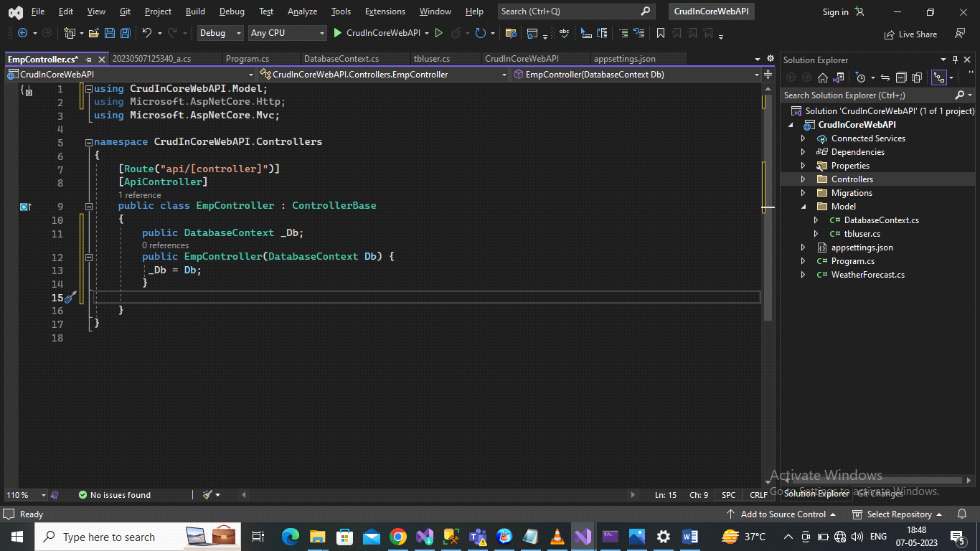

For Data Insert
Add below code
[HttpPost]
[Route("AddData")]
public void AddData(tbluser obj)
{
_Db.Users.Add(obj);
_Db.SaveChanges();
}

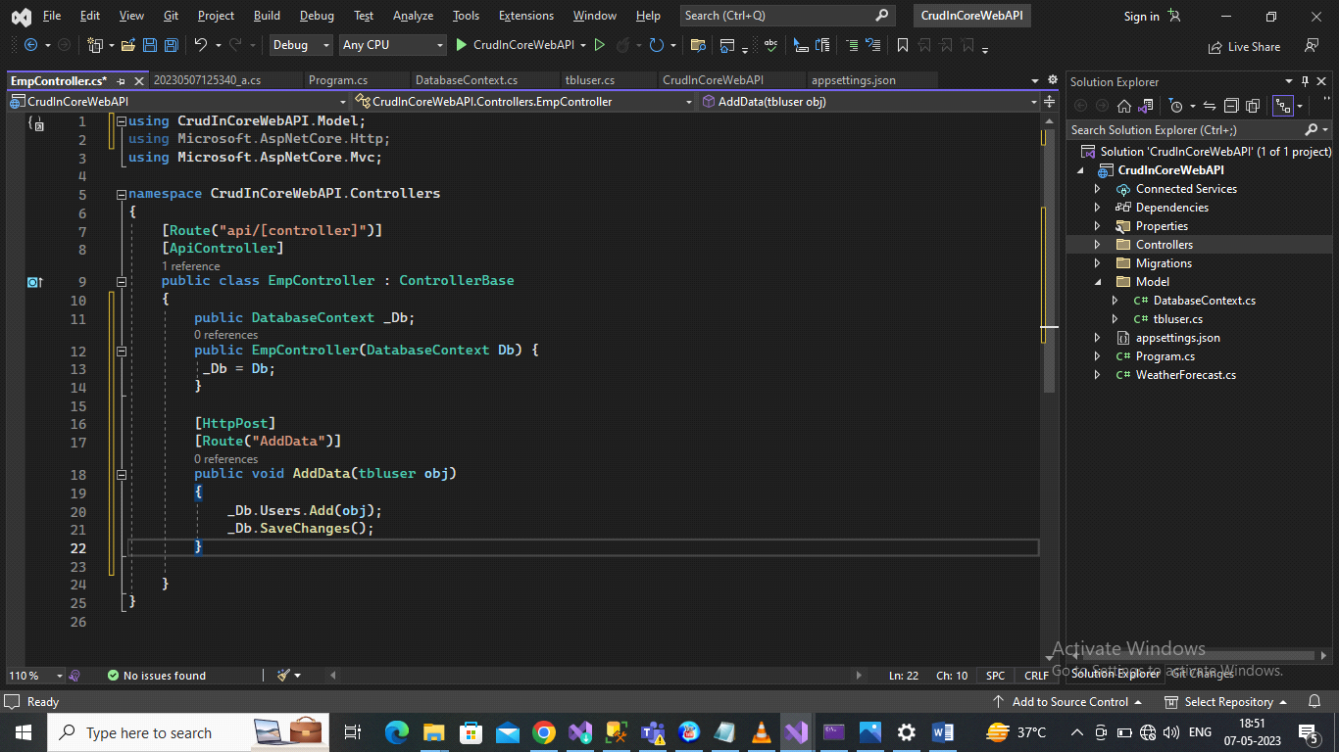

Run Application

OutPut

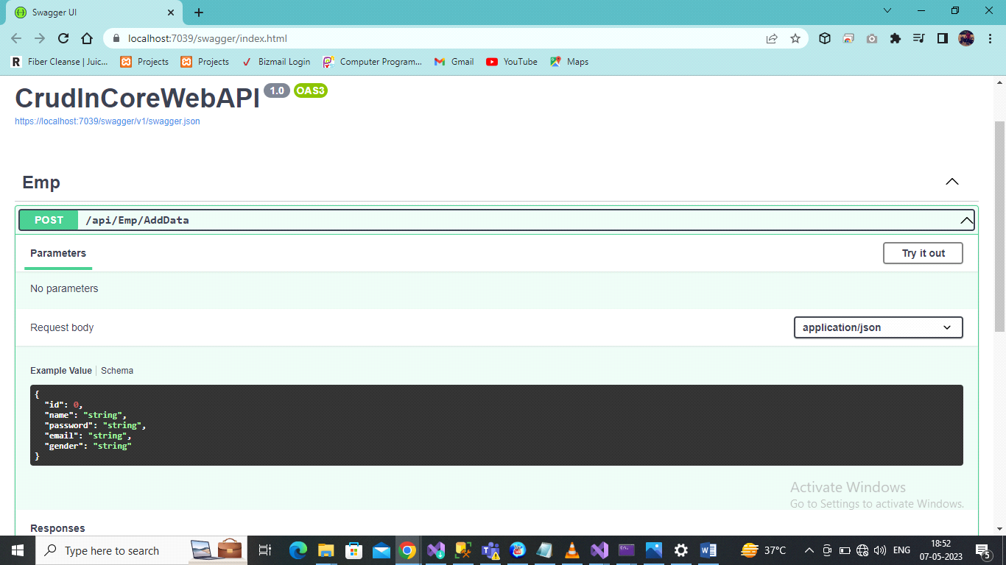
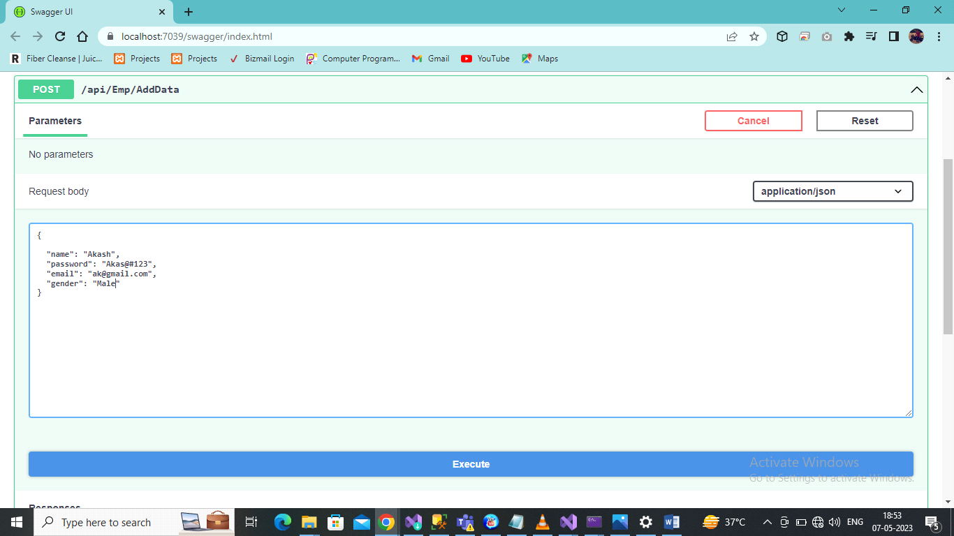

Data is Inserted below show
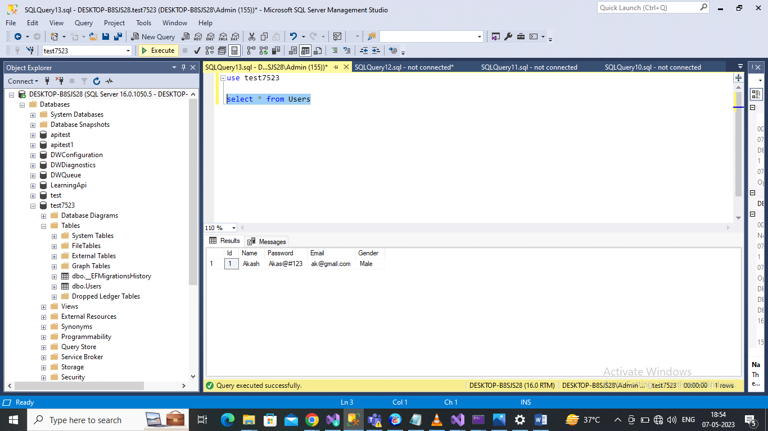

Now Add Code for Get Data from Database

[HttpGet]
[Route("GetData")]
public IActionResult GetData()
{
var data = _Db.Users.ToList();
return Ok(data);
}
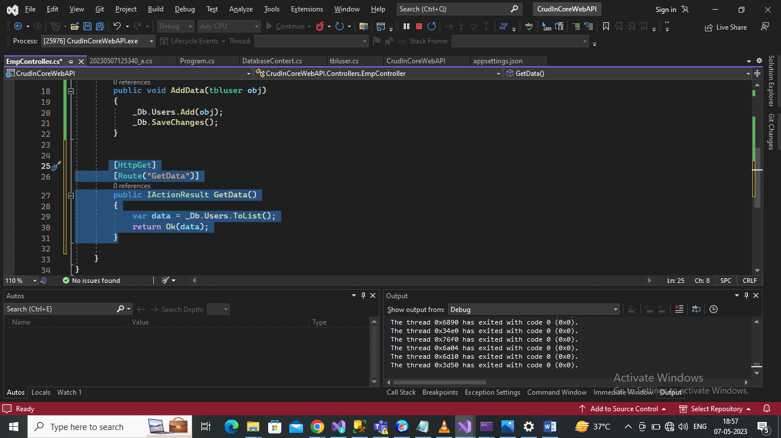
Run Application
Output
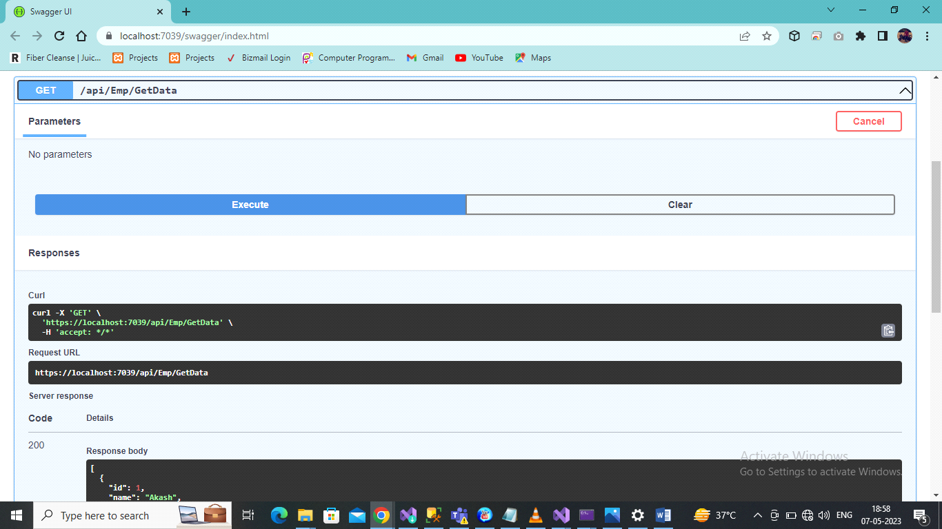

Now Add Code for Get Data By id (Edit)

[HttpPut]
[Route("EditData")]
public IActionResult EditData(int id)
{
var data = _Db.Users.Where(x=>x.Id == id).ToList();
return Ok(data);

}

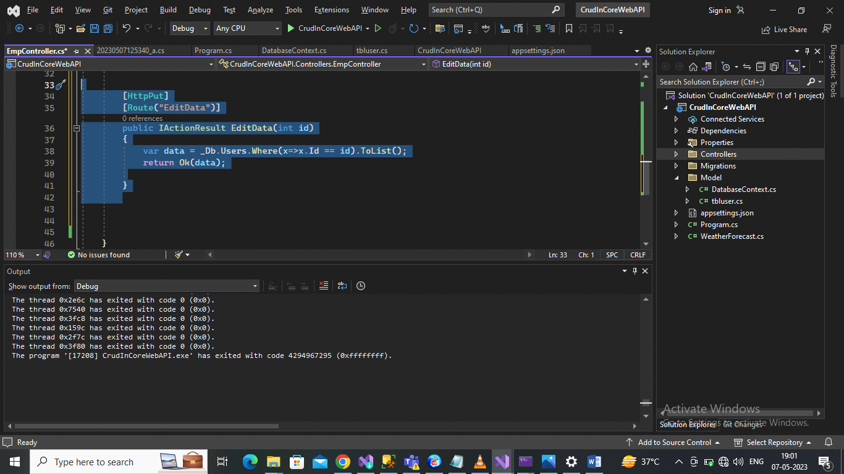
Output
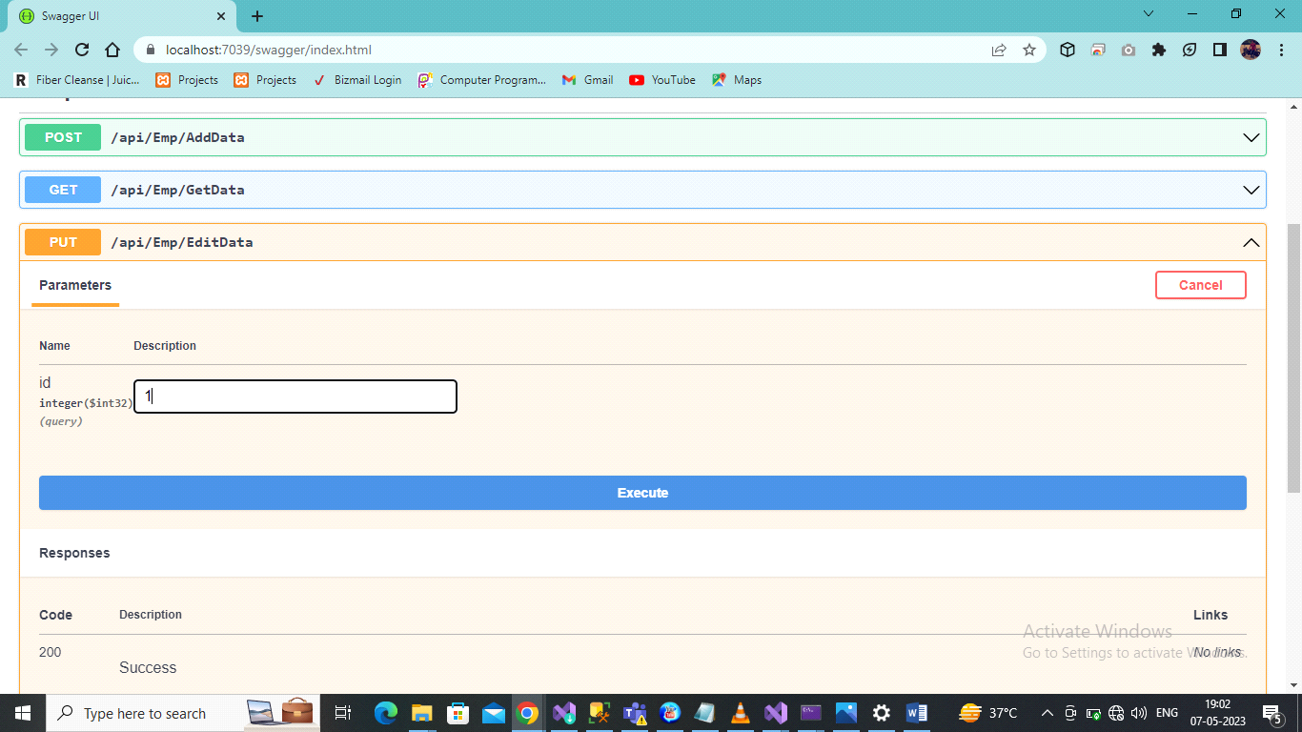
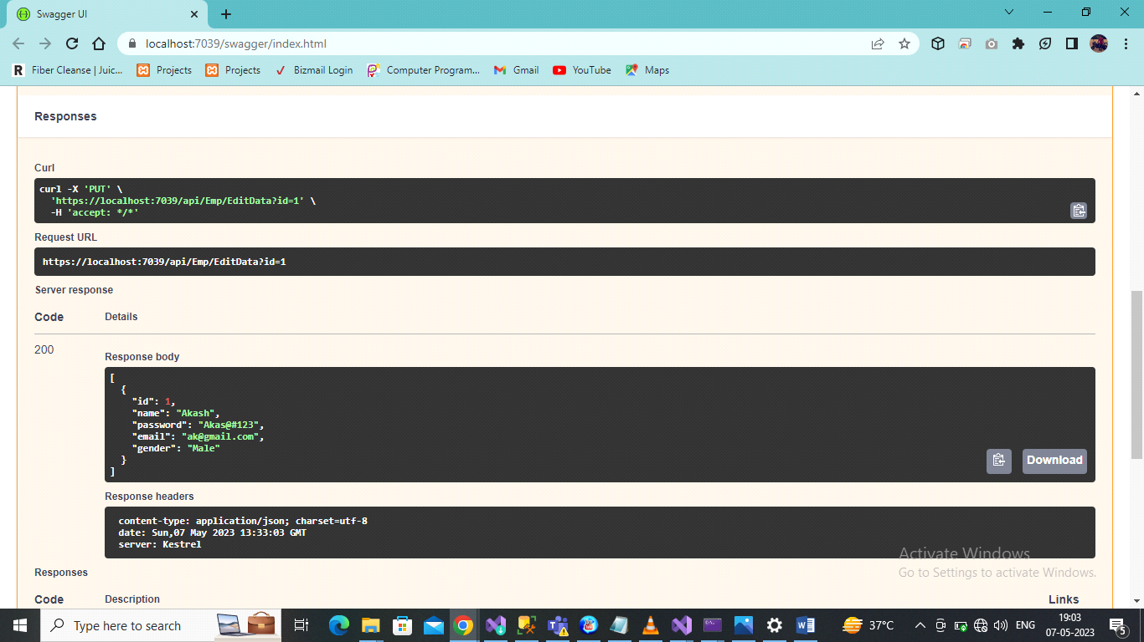

Now add Code for update Data With Id
[HttpPatch]
[Route("UpdateData")]
public void UpdateData(tbluser obj)
{
_Db.Update(obj);
_Db.SaveChanges();
}

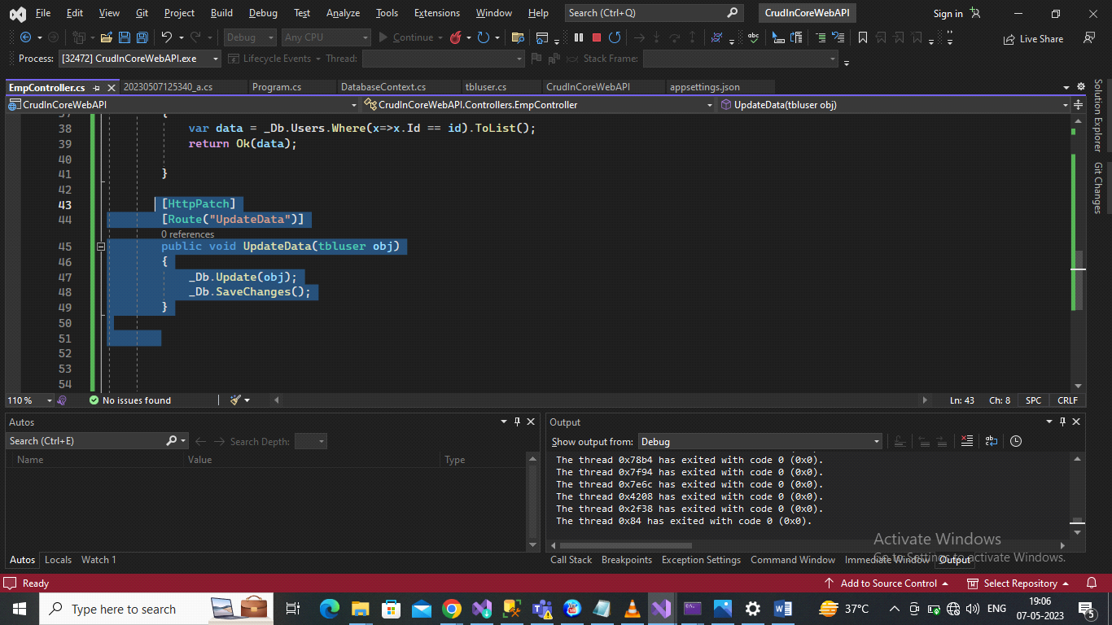

Output
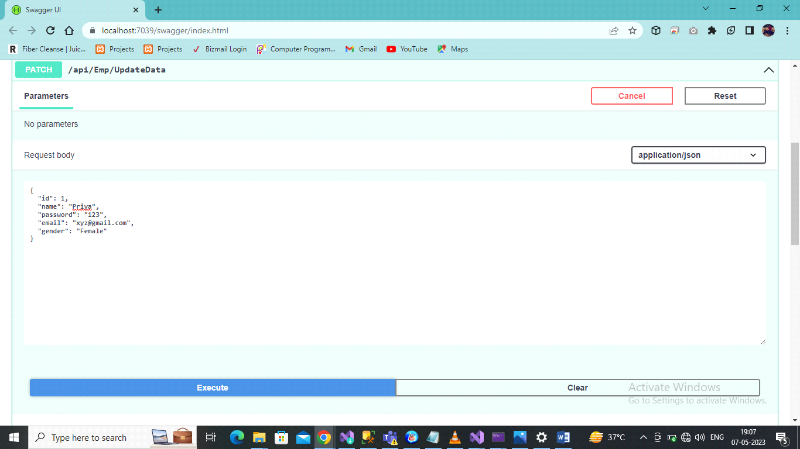
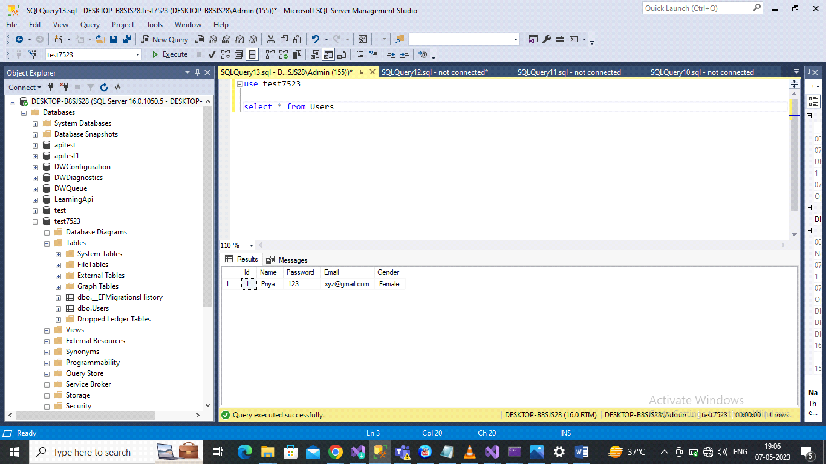

Now Add Code For Delete

[HttpDelete]
[Route("DeleteData")]
public void DeleteData(int id)
{
var data = _Db.Users.Find(id);
_Db.Users.Remove(data);
_Db.SaveChanges();
}
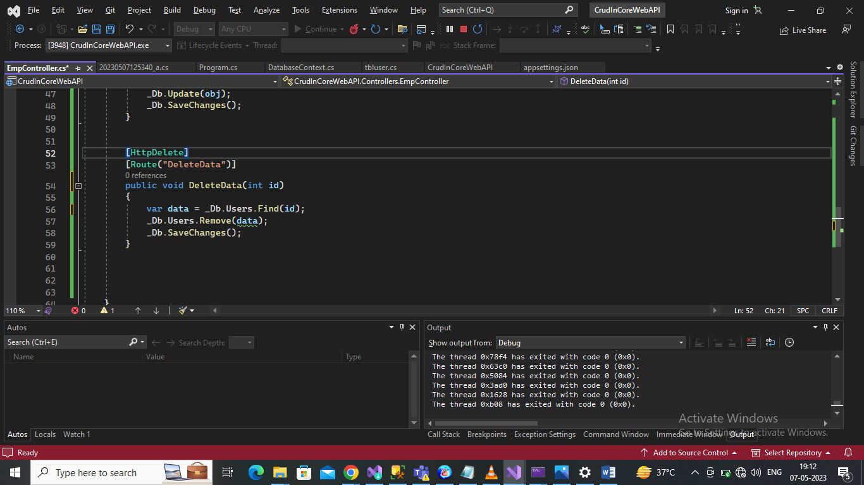
Run Application
Output
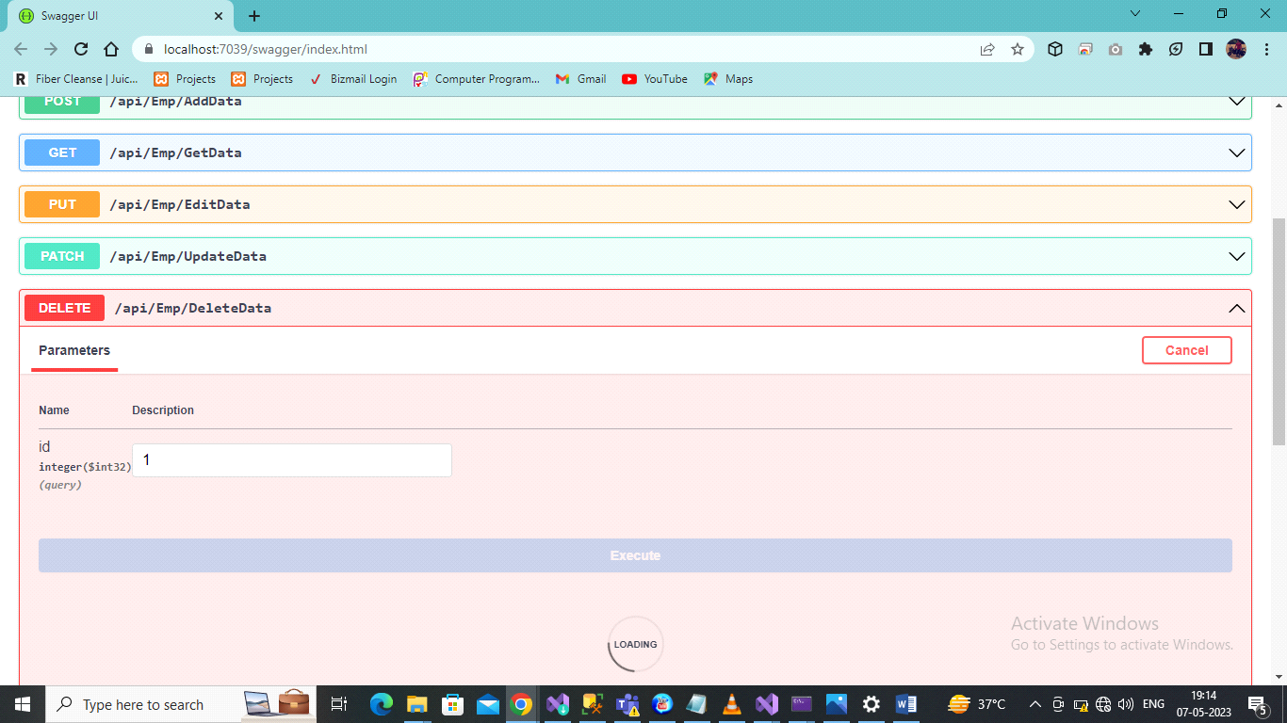
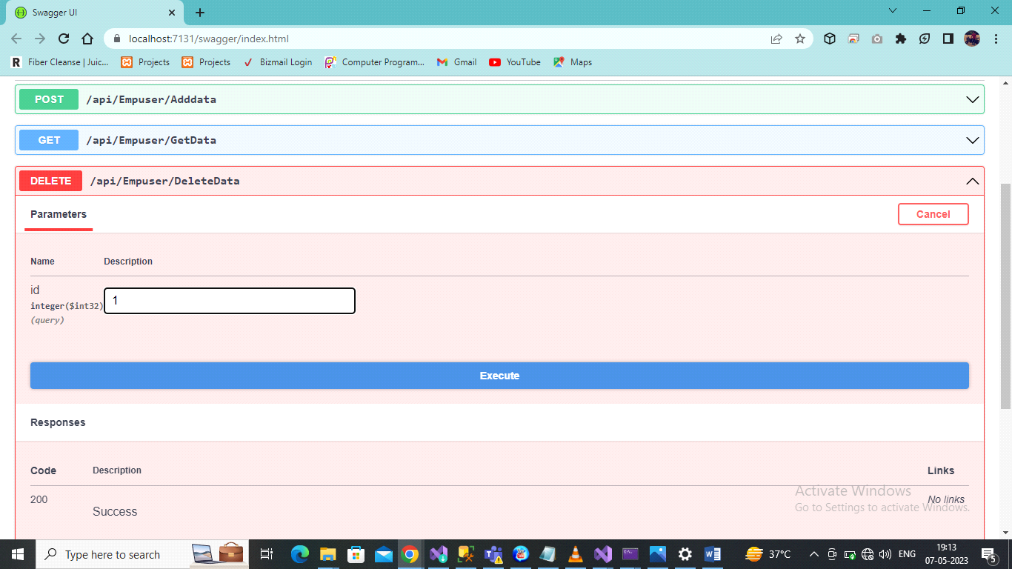

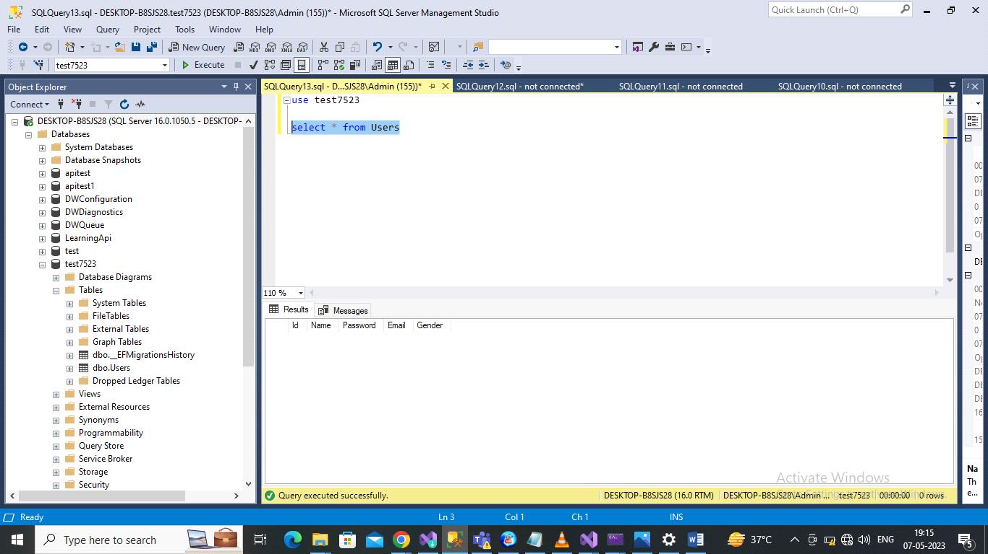

Thanks

akashchoudhary199404@gmail.com

